# Product Catalog Web Form

The project is a single web page displaying a product and allowing the update of a couple of its fields as shown below:

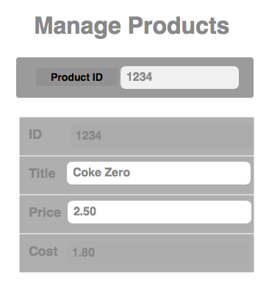

1 - The user must be able to enter a Product Id in the upper search input.

2 - Upon entering the Product Id, an auto suggest must appear under the input, offering a choice of all products ids containing a similar sequence of figures.

3 - Upon clicking Enter, the corresponding product information must be retrieved from the database and fill in the 4 fields of the lower table.

4 - The fields Title and Price must be editable.

5 - Any alpha numeric value containing at least a letter can be entered for the Title, which must be updated in the DB upon clicking Enter.

6 - The Price must be a numeric value and cannot be equal or lower than the cost. It must be updated in the DB upon clicking Enter.

7 - Any wrong value entered must display an error message like "Product 1234 could not be found" or "Title invalid" or "Price invalid"

8 - Feel free to implement any improvement you see fit for this application.

## Technologies

9 - This web app must run on Play 2 Framework ==> http://www.playframework.com

10 - The programming language can be either Java or Scala

11 - The DB must be MongoDB ==> http://www.mongodb.org/

12 - Do not use page re-rendering when clicking Enter, i.e. use Ajax instead of submitting a form to regenerate the HTML on the server side

Use the attached catalog.json as your db product table.

Please return the application as a zip or accessible in a github repo.